“Analyzing E-Learning Platform Purchases using MySQL”
Task
- Table: learners
Attributes:
- learner_id (Primary Key)
- full_name
- Country
- Table: courses
Attributes:
- Course_id (Primary Key)
- course_name
- category
- unit_price
- 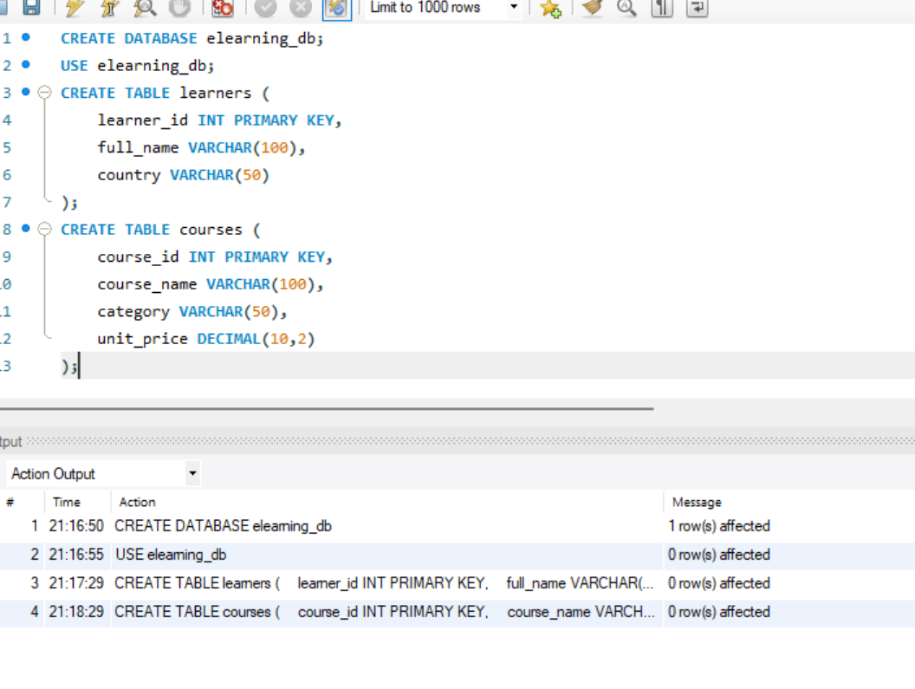
- Table: purchases
Attributes:
- purchase_id (Primary Key)
- learner_id (Foreign Key → learners.learner_id)
- course_id (Foreign Key → courses.course_id)
- Quantity
purchase_date

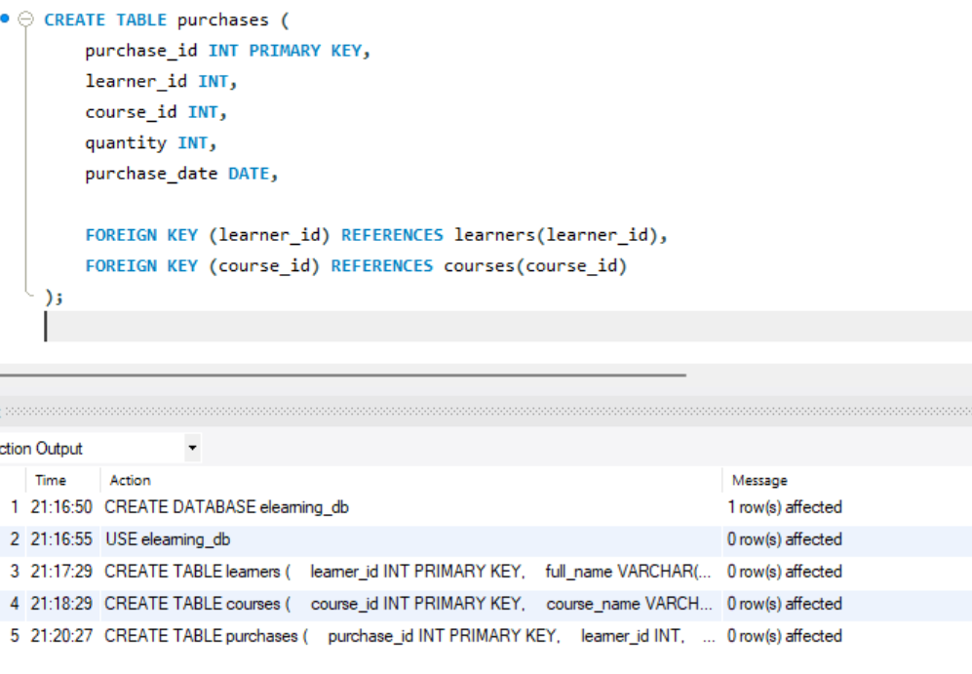

1. Create the database and schema. Populate the Schema:
- Create a Database for this project and
- Create all three tables in MySQL with appropriate data types and relationships.
- Insert sample data covering at least:
  - 4–5 learners
  - 4–5 courses (spread across multiple categories)
  - 6–8 purchase records
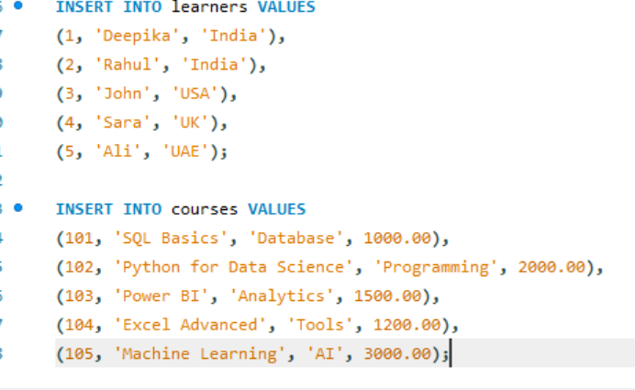

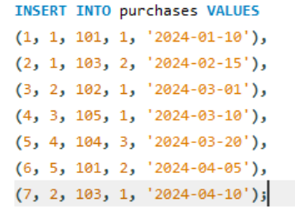
Use SQL INNER JOIN, LEFT JOIN, and RIGHT JOIN to:
- Combine learner, course, and purchase data.
- Display each learner’s purchase details (course name, category, quantity, total amount, and purchase date).

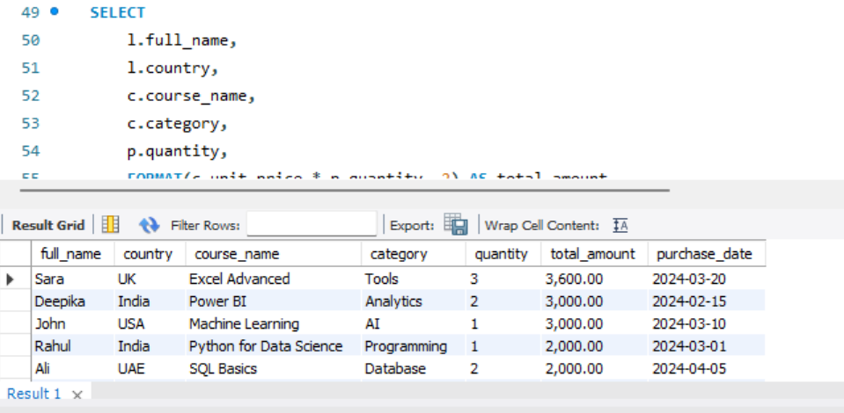

LIFT JOIN:

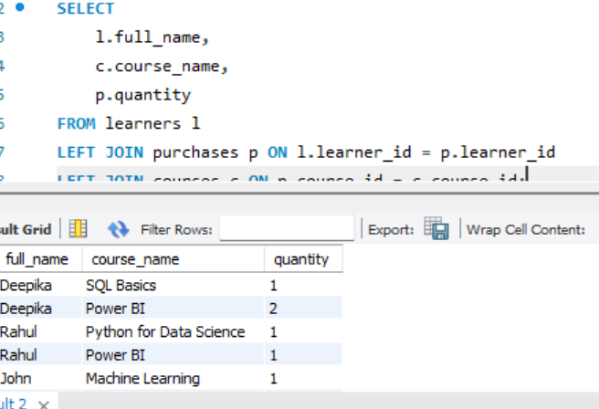

RIGHT JOIN :

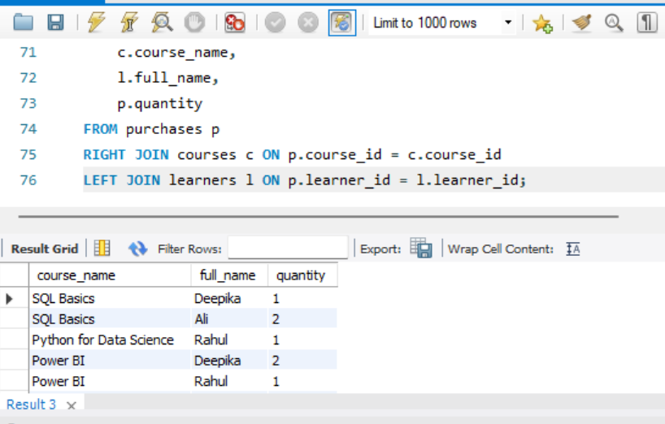

Total Spending per Learner

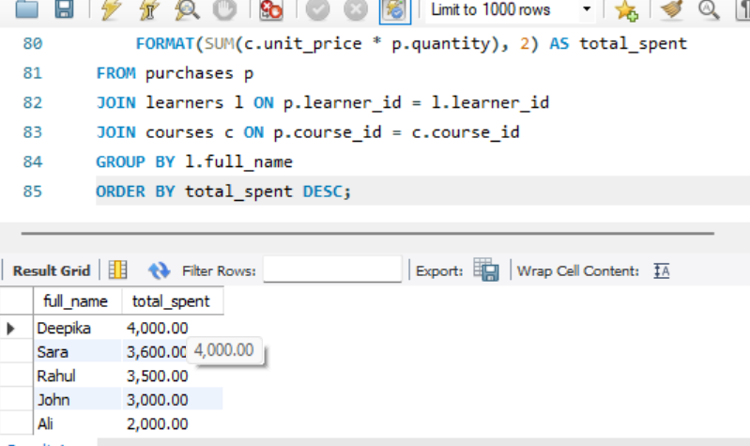

Popular Course Categories

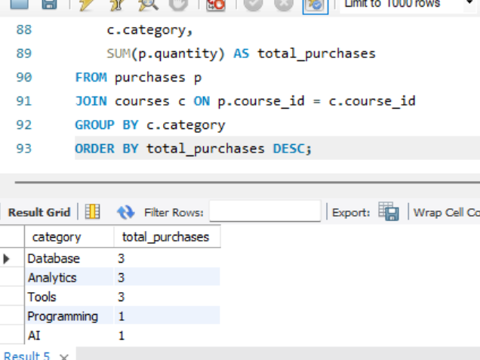

Sales Trend (By Date)

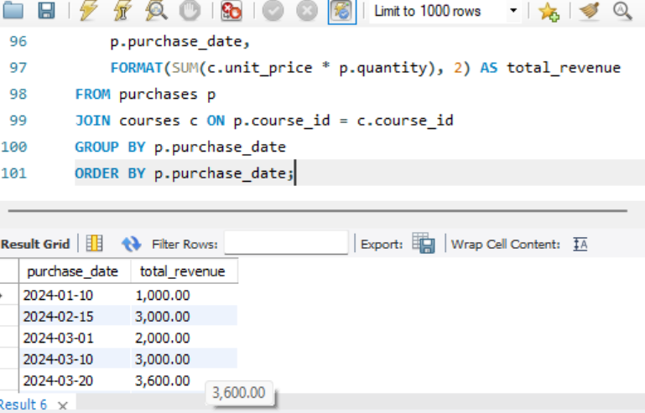
1.Total Spending per Learner
(quantity × unit_price) + country

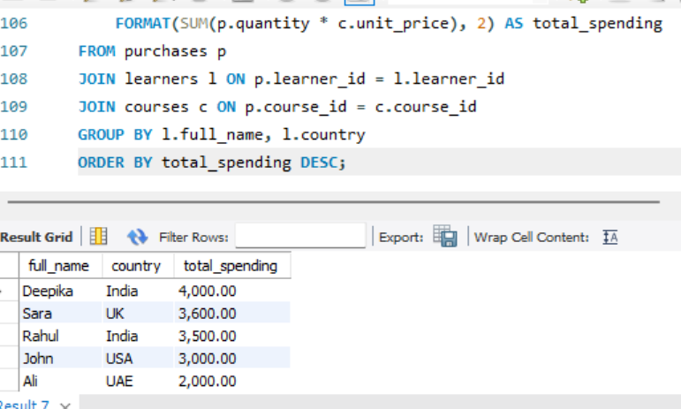

Top 3 Most Purchased Courses
Based on total quantity sold

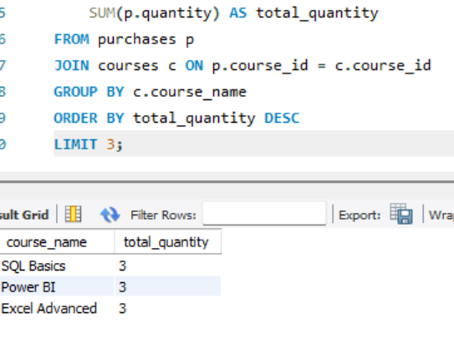

Category-wise Revenue + Unique Learners

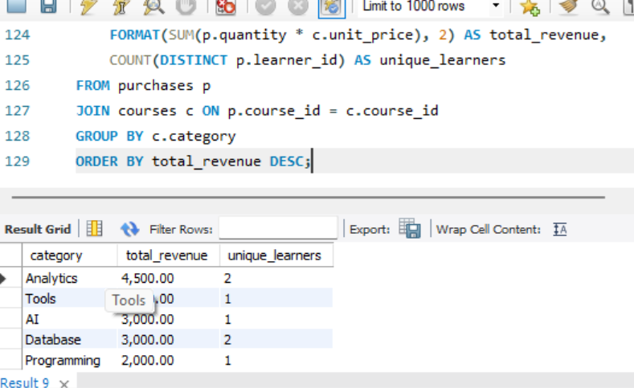

Learners Who Purchased from Multiple Categories

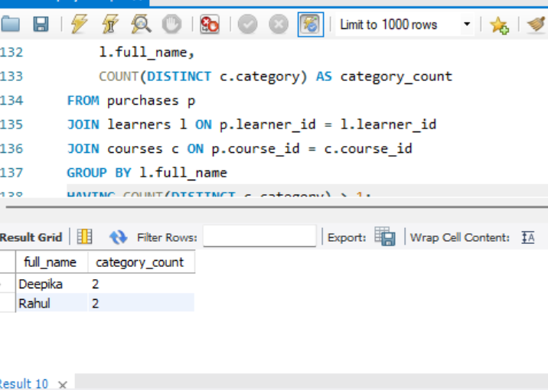

Courses Not Purchased At All

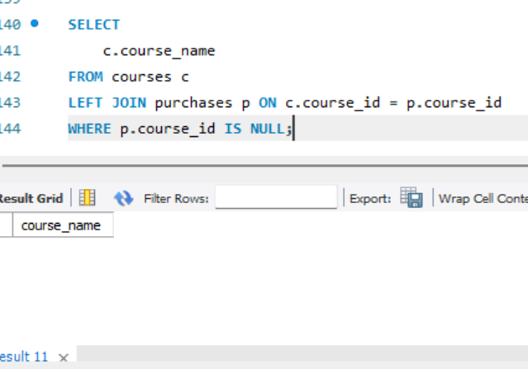

E-Learning Purchase Data Analysis
Overview
This project analyzes purchase data from an online learning platform using MySQL. The dataset includes three main tables: learners, courses, and purchases. The objective was to explore sales trends, learner behavior, and course performance using SQL queries, joins, and aggregations.
Key Insights
- Top Performing Courses:
Courses like Python for Data Science and SQL Basics showed higher purchase quantities, indicating strong demand in technical skills.
- Revenue Analysis:
The AI and Programming categories generated the highest revenue due to higher unit prices and consistent demand.
- Learner Behavior:
Some learners purchased courses across multiple categories, showing interest in diverse skill development and cross-learning trends.
- Category Performance:
Categories such as Database and Analytics had steady sales, while some categories had lower engagement.
- Inactive Courses:
A few courses were not purchased at all, indicating low visibility or lack of interest.
Business Insights
- Learners prefer high-value and career-oriented courses
- Cross-category purchases suggest opportunities for bundled course offerings
- High revenue is driven not only by quantity but also by pricing strategy
Recommendations
- Focus Marketing on Top Categories:
Promote high-performing categories like AI and Programming to maximize revenue.
- Improve Low-Performing Courses:
Offer discounts, update content, or improve marketing strategies for courses with no purchases.
- Introduce Course Bundles:
Combine related courses (e.g., SQL + Power BI) to increase cross-selling.
- Personalized Recommendations:
Suggest courses based on learner purchase history to improve engagement.
- Monitor Trends Regularly:
Track purchase patterns over time to adjust pricing and promotions effectively.
Conclusion
The analysis provides valuable insights into learner preferences, course popularity, and revenue trends. By leveraging these insights, the platform can enhance its offerings, improve customer engagement, and drive overall business growth.

